OCI Integration
Generate Access Token to Provision OIC Instance

Table of Content

Purpose statement 3
Create the Application 4

Purpose statement
This document aims to illustrate the setup and steps to generate the access token needed as part of the CI/CD to provision infrastructure in the Oracle cloud. This will cover the below topics,
- Application configuration
- Generate the Access Token

Create the Application
Before you can provision an Oracle Integration instance as a user, we need to create an application.

  - Open the Oracle Cloud Infrastructure navigation menu, click Identity & Security, and click Domain.

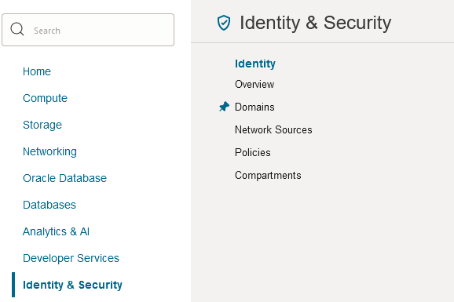

  - Select the Domain to create the Application.

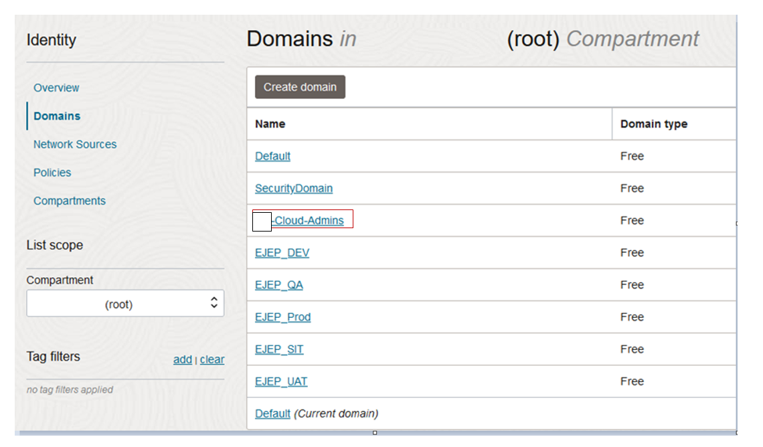

  - Click Applications under Overview.
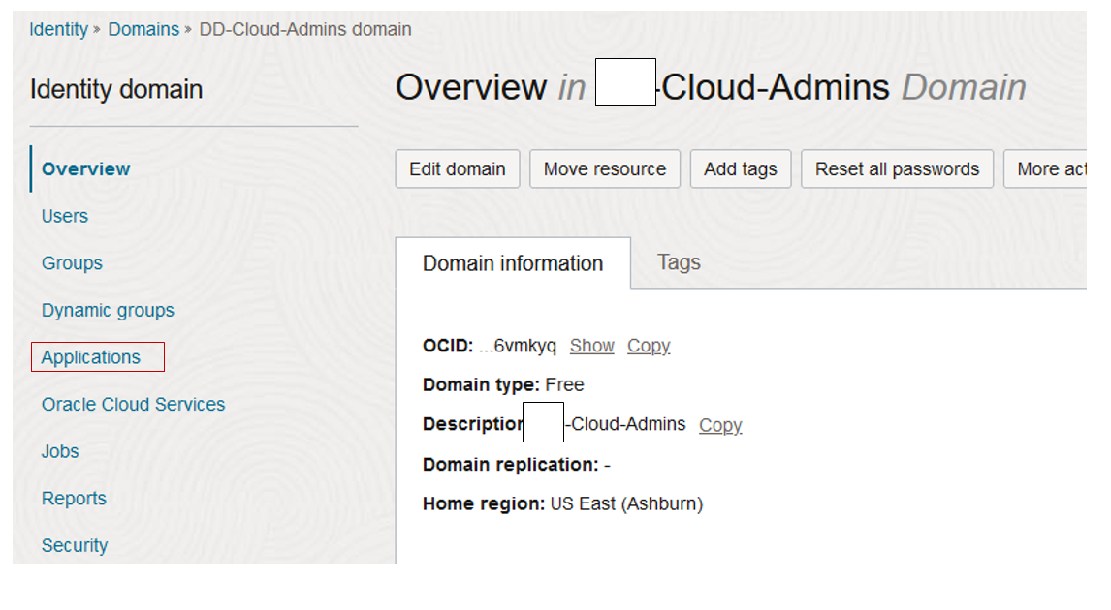

  - Click Add Application.
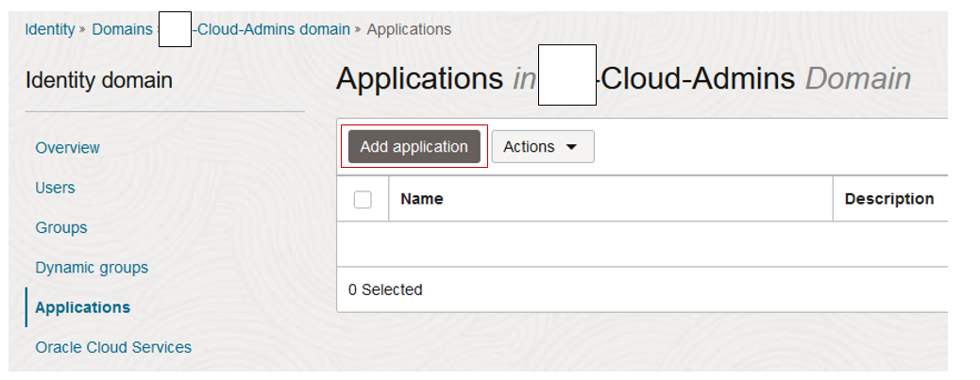

  - Click Confidential Application. And Click Launch workflow. This starts the Add Confidential Application Wizard.

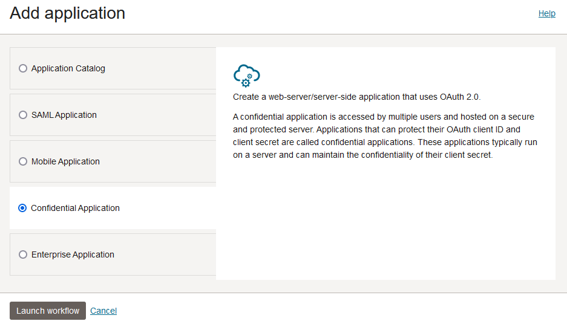

  - In the Add applications details page, enter the Name: < OIC-App> and leaving the rest of the fields default, click Next.
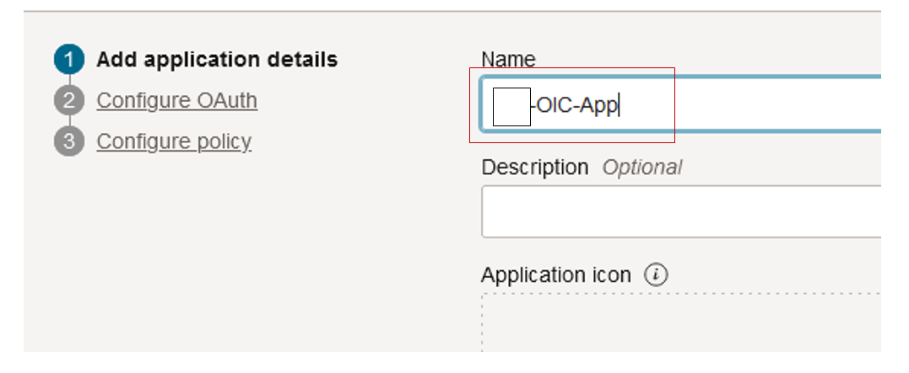

  - In the Configure OAuth page, Under Resource Server Configuration, select Configure this application as a resource server now and enter the following fields.
- Access Token Expiration: 3,600 seconds.
- Allow Token Refresh: Select the check box.
- Refresh Token Expiration: 604,800 seconds.
- Primary Audience: https://oic-app.com/
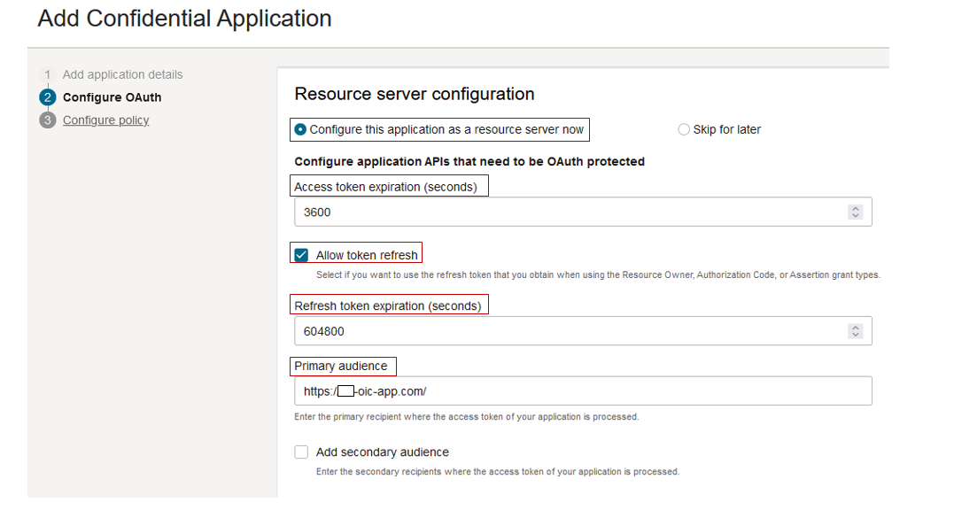

- Add scopes: Check the box and enter the following fields:
Scopes: < oicapp >
and click Add.

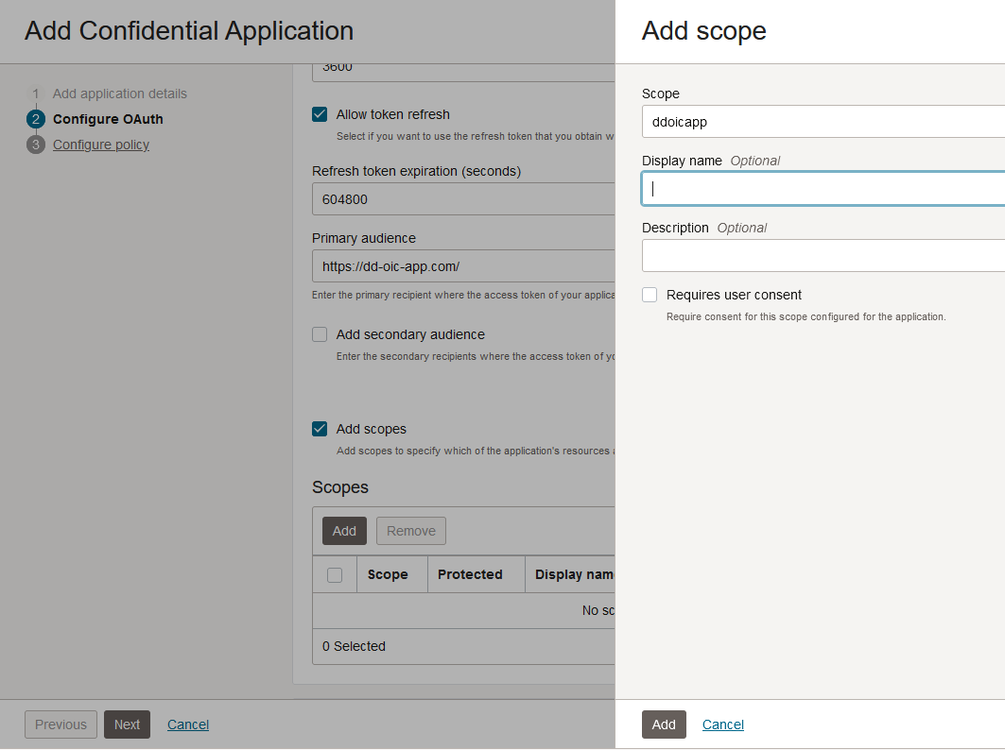

- In the Configure OAuth page, Under Client Configuration, select Configure this application as a client now and provide the following details for client authorization:
- Allowed Grant Types: Resource Owner Client Credentials, JWT Assertion
- Allowed Operations: Introspect
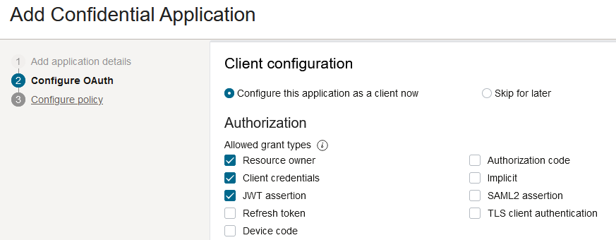

- Client Type: Confidential
- Allowed operations: Introspect
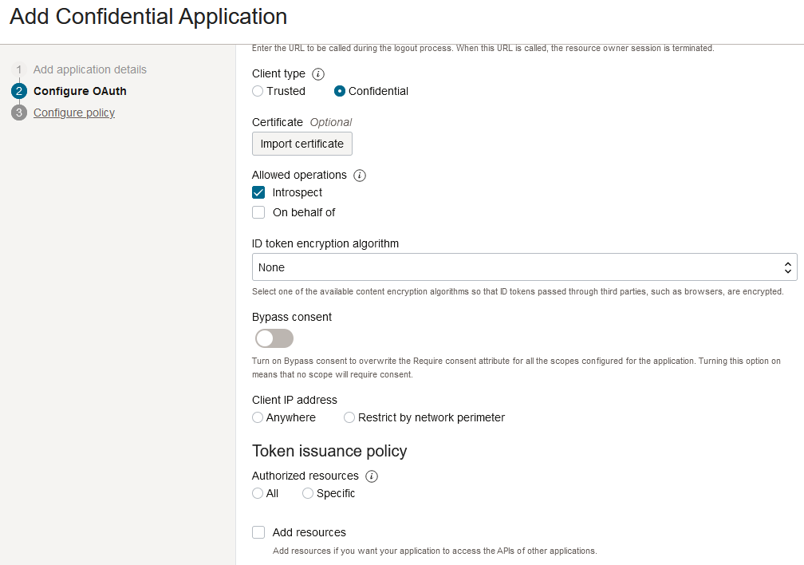
- Under Token issuance policy, select Add app role and click Add roles, then select: Identity Domain Administrator and the select Add
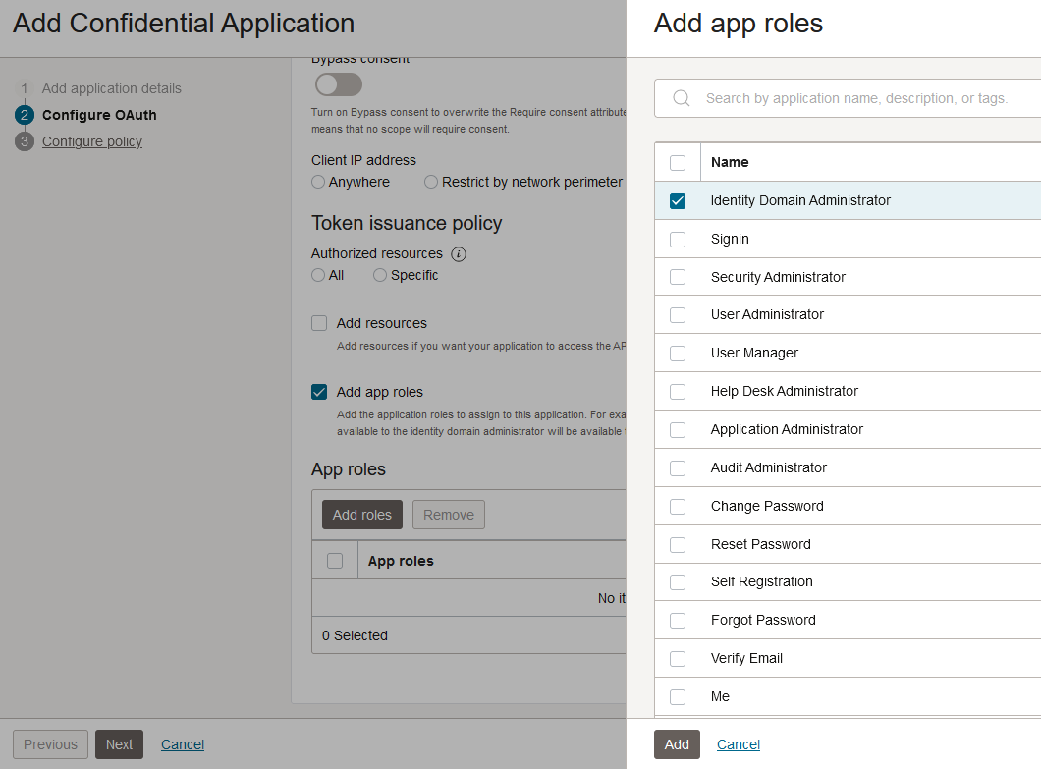
- Configure OAuth page and click Next to proceed to the Configure Policy page.

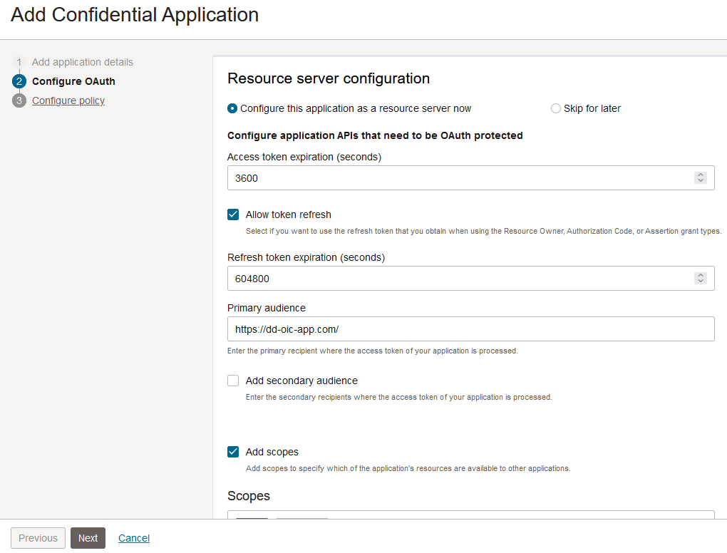

- Under Configure policy page, for the Web tier policy, select Skip and do later and click Finish

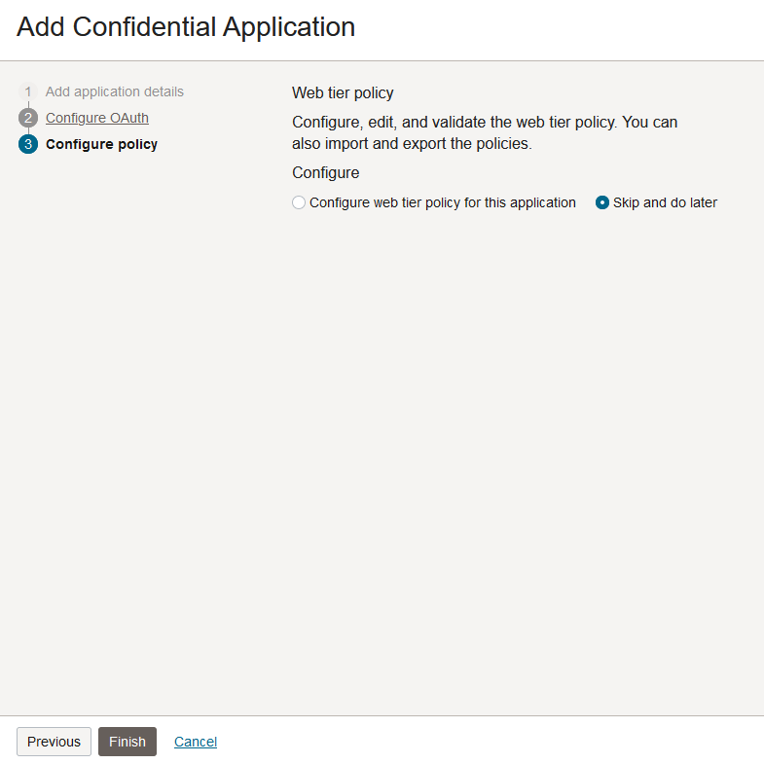

- Click Activate, to active the application created.
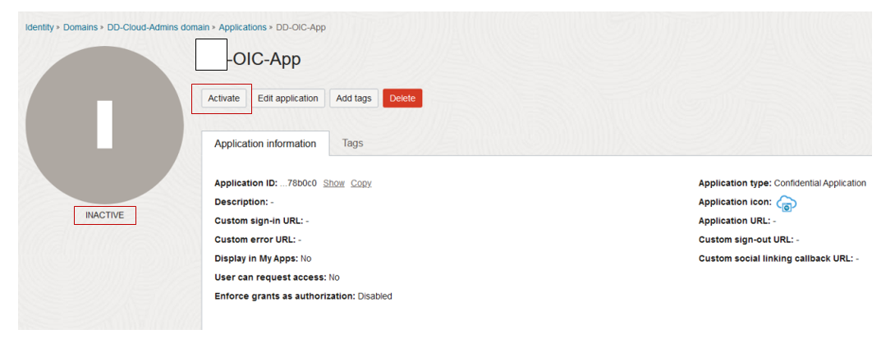

- Confirm Activate Application
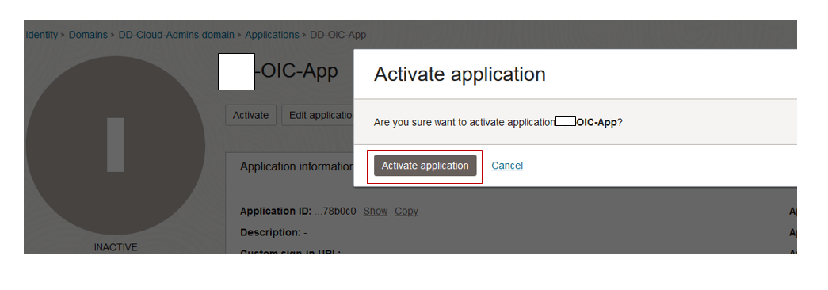

- The application (named OIC-App) is created and is ready to use to generate the access token for the users.
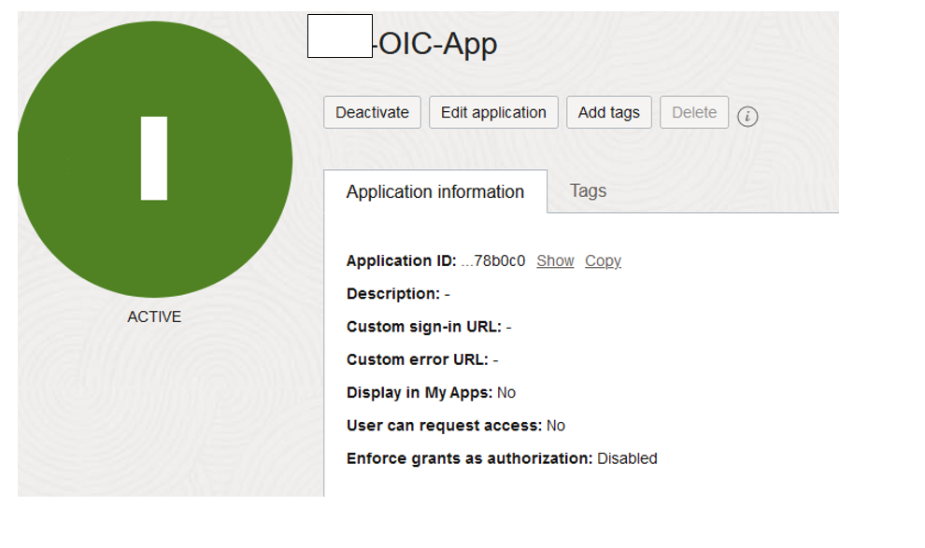

### END ###

